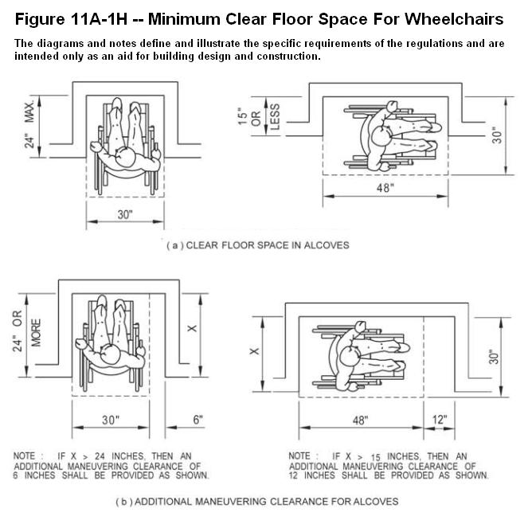
ADA Accessible Lockers

Purpose of this document
To provide a high-security design and quality construction for electronic lockers that can be customized to conform to the Americans with Disabilities Act (ADA) locker requirements for accessibility and usability.

This document provides guidance to installing locker units to provide service in compliance with ADA guidelines for wheelchair reach requirements. The vertical location of the locker unit’s lowest shelf location “above the finished floor” (AFF) controls the quantity of locker compartments that comply with the reach requirements.

ADA Compliance – Many Metal Lockers and Wood Lockers meet ADA reach requirements when a shelf is installed at heights listed in the installation details below. The Americans with Disabilities Act section that covers clear space and reach dimensions is noted below:

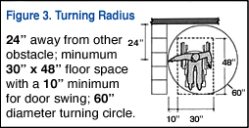
Turning Radius Recommendation
Lockers should be placed in an area that allows full door swing and wheelchair turning ability. Lockers shall be placed in a location at least 24" away from any wall or other obstacle and have a minimum clear floor space of 30" x 48" with a 10" minimum for door swing. The area in front of the locker must be clear within a 60" diameter turning circle to allow for unobstructed access. See Figure 3.

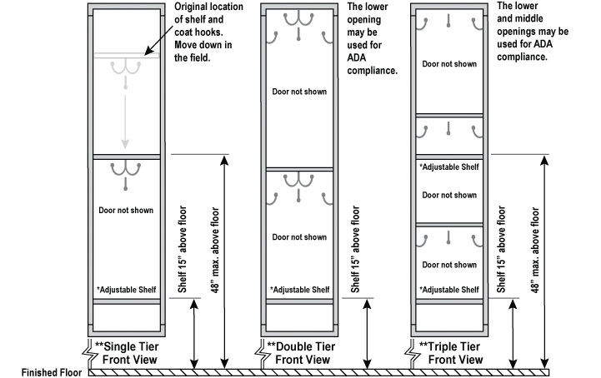
* Locker shelves are adjustable to meed ADA guidelines.
** Locker leg or base height can vary depending on installation desired. From zero (0) inches A.F.F.
(metal lockers without legs or wood lockers without bases) to six (6) inches A.F.F. (metal lockers with legs).
ADA Compliant Metal Lockers
The Americans with Disabilities Act (ADA) specifies certain requirements that affect metal lockers. To comply, at least 5% of the lockers provided, but no less than one locker, needs to meet the ADA requirements.
ADA Compliant Triple Tier Locker
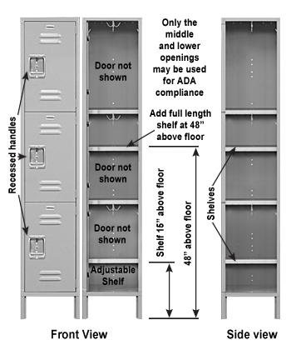
1127A.6 Lockers - 1127A.11 Storage.
1127A.11.1 General. If fixed storage facilities such as cabinets, shelves, closets or drawers are provided to residents or guests, at least one of each type of facility provided shall comply with this section and at least one locker, and not less than 1 percent of all lockers, shall be accessible to persons with disabilities.
1127A.9.5 Reach ranges.
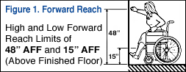
Forward Reach Requirement
Section 308.2 – 1127A.9.5.1 forward reach. If the clear floor space allows only forward approach to an object, the maximum high forward reach allowed shall be 48 inches (1219 mm) and the minimum low forward reach shall be unobstructed and no less than 15 inches (381 mm) above the floor (see Figure. 11A-1I(a)).
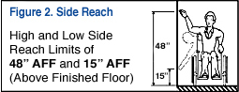
Side Reach Requirement
Section 308.3.1 – A clear floor or ground space allows a parallel approach to an element and the side reach is unobstructed, the high side reach shall be 48 inches (1220 mm) maximum and the low side reach shall be 15 inches (380 mm) minimum above the finish floor or ground.” See Figure 2.

1127A.9.6.3 If the reach is over an obstruction (for example, washer or dryer) between 20 and 25 inches (508 and 635 mm) in depth, the maximum height is reduced to 44 inches (1118 mm) for forward approach, or 46 inches (1168 mm) for side approach, provided the obstruction is no more than 24 inches (610 mm) in depth.
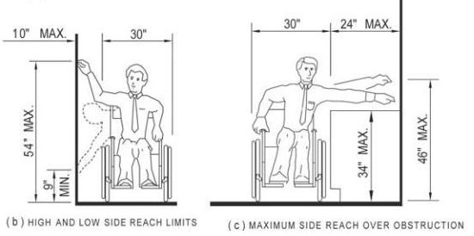
1127A.9.5.2 Side reach. [Also known as parallel reach] If the clear floor space allows parallel approach by a person in a wheelchair, the maximum high side reach allowed shall be 54 inches (1372 mm) and the low side reach shall be no less than 9 inches (228.6 mm) above the floor (see Figure 11A-1J(a) and 11A-1J(b)). If the side reach is over an obstruction, the reach and clearances shall be as shown in Figure 11A-1JC).

1127A.9.6.4 Operation. Controls and operating mechanisms shall be operable with one hand and shall not require tight grasping, pinching or twisting of the wrist. The force required to activate controls shall be no greater than 5 pounds (22.2 N) of force.
1117B.5.8 Symbols of accessibility.
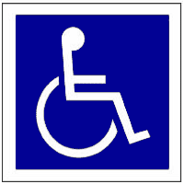
1117B.5.8.1 International Symbol of Accessibility. The International Symbol of Accessibility shall be the standard used to identify facilities that are accessible to and usable by physically disabled persons as set forth in these building standards and as specifically required in this section. (SeeFigure 11B-6).

